Choose TMT Bars Over HYSD Bars for Your Home: Here’s Why
HYSD (High Yielding Strength Deformed) bars and TMT (Thermo Mechanical Treatment) bars are contenders to choose from while selecting steel for reinforcing concrete when making a home or any other structure. In this blog, we help you understand the difference between the two so that you can make the right choice when building your home.

The making of HYSD bars involves a specific treatment after undergoing the heat treatment: the bars are heat rolled or cold twisted so that they can be moulded into a shape.

Difference between HYSD and TMT Bars
1. Unlike HYSD bars, TMT bars undergo both heat treatment and cold treatment. The hot billets are passed through water for cooling purposes. This is the process of quenching. As a result, they have an outer core that is hard and an inner core that is soft.

2. Again, unlike HYSD bars, TMT bars are not twisted into a shape. As a result, surface cracks do not appear on their surfaces. They do not display any other signs of defects either.

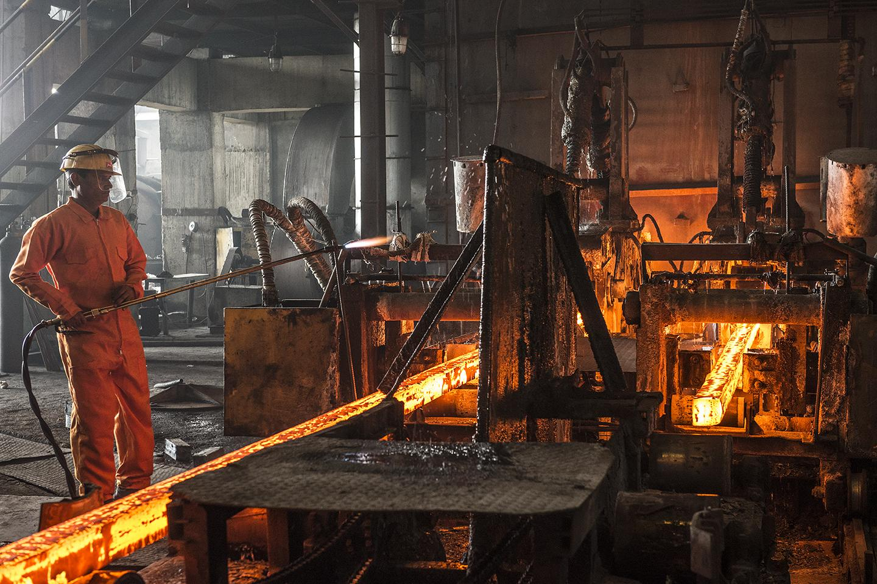
Advantages of Using TMT Bars
1 The lack of defects on the surface of TMT bars makes them less prone to residual stresses than HYSD bars.

2. The hard outer layer makes the TMT bars stronger than HYSD bars.

3. The soft inner layer makes the TMT bars acquire tensile strength greater than HYSD bars can display.

4 TMT bars are therefore more ductile and can withstand all kinds of pressures and shocks very well.

5. HYSD bars require an elaborate process for hardening. But because TMT bars are hardened through quenching, they are produced with a reduced production cost. And the benefit is passed on to you too because they remain affordable and effective.

In a nutshell, TMT bars:
· cost you less
· make your home stronger and safer for your family to live in

So before finalising the raw materials for building your home, remember to check with your dealer regarding all the bars being shown to you. Speak to our experts for more information.

Meta description: In this blog, we help you understand the difference between the HYSD and TMT bars so that you can make the right choice when building your home.

