Why Steel for Your Home? 5 Critical Factors to Consider

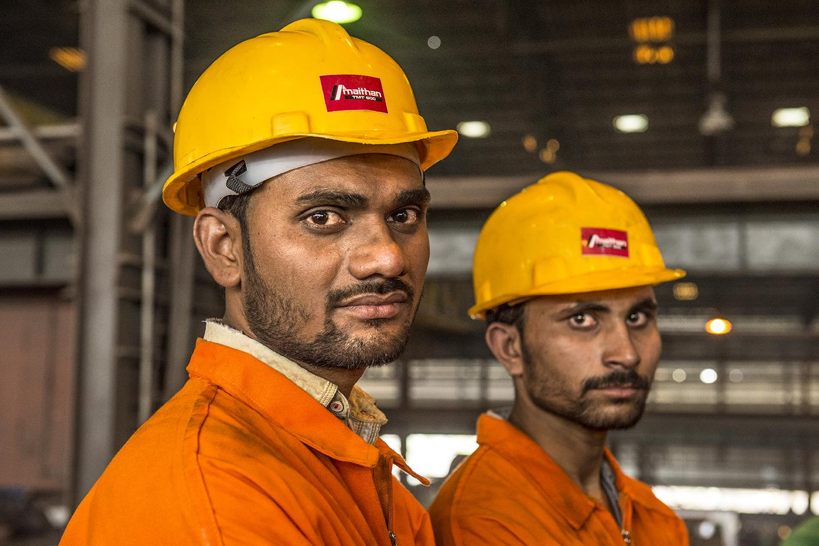

A home is nothing if it’s not made from the strongest materials. Steel is blended with concrete while building homes – an ideal combination for stronger, safer homes. Steel has a huge role to play in this idea of safety.

Let’s look at 5 critical factors that make steel an outstanding element and an ideal choice in building homes and other infrastructure projects.

1. Steel comes with a ductility and malleability that makes a structure bend in the event of an earthquake. A concrete structure without the reinforcement of the steel will crumble quickly.

2. Steel can also resist compression or pressure very well. It has a tensile strength greater than that of concrete – which makes it withstand structural challenges.

3. Like concrete, steel can withstand extremely high temperatures thus naturally complimenting each other. This makes a structure last long.

4. Steel can be easily welded – a quality that helps when building elaborate frameworks that require securing the joints very well.

5. Steel is economically available. Designing another product with the similar ductility and malleability would turn out to be the most expensive affair.

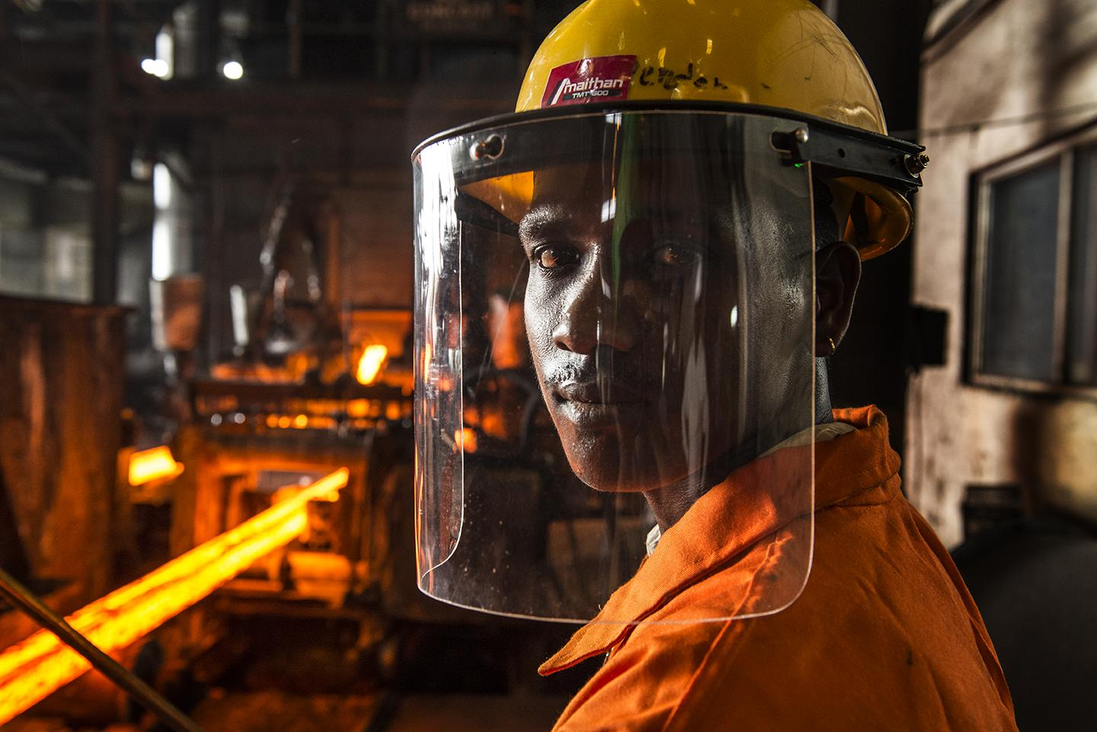

The point is that steel is very versatile and complements concrete very well. It is impossible to imagine a structure standing erect without the assurance of steel.

Steel, also known as white gold, brings strength to a building. It also has the flexibility to bend when the need arises so that it does not break.

It is critical for you to investigate the kind of steel that is going into the home you are building or a project you are creating. The grade of steel you use determines the life of your structure.

Meta description: Let’s look at 5 critical factors that make steel an outstanding element and an ideal choice in building homes and other infrastructure projects.

